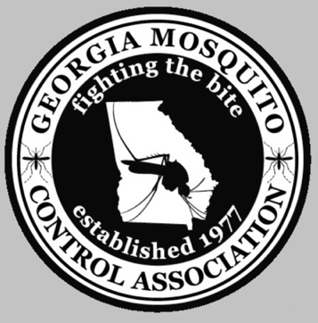
GMCA Commercial Membership Form

For COMMERCIAL PEST CONTROL Companies ONLY

Please complete the form and enclose $150.00 for Dues Only. Membership dues are for one year.

Make check payable to:
Georgia Mosquito Control Association

Date:

Company*:

Street Address:

City: State: Zip:

Phone: Fax:

# Employees:

Email:

Send this completed form and check to:

GMCA c/o: Misty McKanna
1386 Kelly Rd, Statesboro, GA 30461
Phone: 912-670-1140
Misty.McKanna@dph.ga.gov

*This is how your company will be posted on the GMCA website. (http://www.gamosquito.org/commercialmemb.htm)

