Chatham County Mosquito Control Pesticide Discharge Management Plan

Chatham County Mosquito Control

65 Billy B. Hair Drive

Savannah, GA 31408

(O) 912-790-2540

(F) 912-790-2550

- Pesticide Discharge Management Team. All persons may be contacted at: Chatham County Mosquito Control, 65 Billy B. Hair Drive, Savannah, GA 31408, (O) 912-790-2540, (F) 912-790-2550

  - Person(s) responsible for managing pests in relation to the pest management area.

    - Director
    - Assistant Director

  - Person(s) responsible for developing and revising the PDMP.

    - Director
    - Assistant Director

  - Person(s) responsible for developing, revising, and implementing corrective actions and other effluent limitation requirements.

    - Director
    - Assistant Director

  - Person(s) responsible for pesticide applications (mix, load, apply).

    - Director
    - Assistant Director
    - Entomologist
    - Entomology Technician
    - Ground Adulticiding Supervisor
    - Assistant Ground Adulticiding Supervisor
    - Mosquito Control Operator
    - Equipment Mechanic
    - Chief Pilot
    - Pilot/Mechanic
    - Chief of Aircraft Maintenance
    - Aircraft Service Technician
    - Maintenance Services Supervisor
    - Equipment Operator/Mechanic
    - Lead Maintenance Worker

- Pest Management Area Description
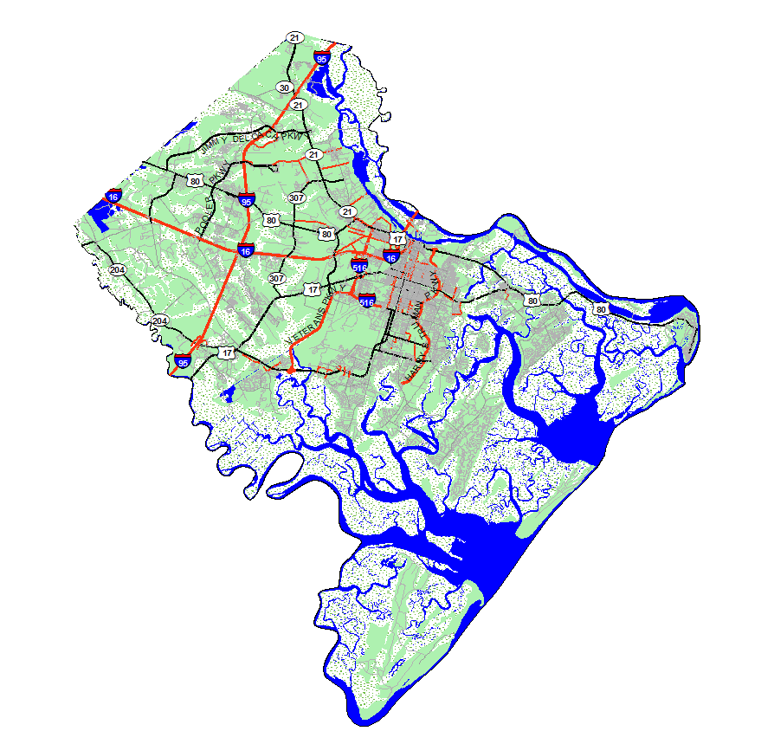
  - Pest Problem Area Description: Chatham County is located in the eastern corner of Georgia within the Lower Coastal Plain Physiological Region of the state. It is bordered by the Atlantic Ocean to the east; the Savannah River to the north; the Ogeechee River to the south; and Effingham County to the west. Chatham County has a land area of 441 square miles, or 282,240 acres (USDA, 1974). Pest problem areas can best be separated into 2 broad types within our service area that can be further divided into more specific groups based on habitat type.
      - Natural Environments
        - River and creek floodplains in Chatham County are associated with the 3 major freshwater river systems (Savannah River, Ogeechee River, and Little Ogeechee River) and the tributaries that flow into these. These floodplains are characterized by river cypress, black gum, Ogeechee lime, water tupelo, water oak, and other hardwoods. Mosquito species commonly found in these environments include Culiseta melanura, Psorophora ferox, and a number of floodwater species of Ochlerotatus genus.
        - Coastal and intercoastal islands, hammocks, and high marsh areas are dispersed throughout our coastal region. These areas are affected by high river stages in the spring, rains, and tides. Ochlerotatus taeniorhynchus and Oc. sollicitans are major problems in these areas, although Culex salinarius is also common to such sites.
        - Woodland ponds, pools, and depressions are isolated wetlands occurring throughout the county within in forested uplands and pasture areas. Examples of these habitats include gum ponds, cypress ponds, cypress strands, sloughs, and depressions caused by uprooted trees. Many of these sites only contain water during the wet seasons of the year, and serve as excellent nurseries for most species of mosquitoes found in our region.
        - Other natural environments include springs, seeps, tree holes, tree cavities, burrows made by various species of wildlife. However, these as a whole are generally not a pressing concern to our mosquito program, although tree holes play a major role in the biology of Ochlerotatus triseriatus which is the primary vector of La Crosse virus in the United States.
      - Man-made Environments
        - Ditches and canals are frequently suggested as sources of mosquito problems by the general public. However, these structures usually contain fish, and are seldom the primary source of a mosquito infestation, especially if these systems tend to hold water on a permanent basis. On the other hand, shallow, roadside ditches do contribute to mosquito populations at times. Such sites often remain dry throughout much of the year or because of temperature, oxygen content, or other factors do not support fish life. Mosquito species encountered in such sites include Aedes vexans, Culex salinarius, Cx. restuans, and many species of Ochlerotatus.
        - Clear-cuts are the result of logging operations for the timber industry or future residential subdivisions. Often such work tends to scar the land with trenches and ruts from the heavy equipment used in the process. These newly established “lows” can hold water for prolonged periods of time, especially without the aid of water translocation previously carried out by the now absent forest. Often such sites are productive as larval mosquito sites until they are developed or regenerate. Initially, such sites may harbor Culex mosquitoes, including Cx. quinquefasciatus, because of the excess of rotting plant material left after clear-cutting work.
        - Livestock pastures can pose a serious problem to mosquito abatement agencies, as the livestock not only provide a reliable blood meal for female mosquitoes, but form numerous larval habitat from their hoof prints. Mosquito species associated with pastures include Aedes vexans, Culex quinquefasciatus, and Psorophora columbiae.
        - Storm drains and catch basins are found in the more developed areas of the county, and provide a pristine environment for Culex quinquefasciatus, our primary WNV vector.
        - Containers come in all sorts of shapes and sizes. These may be represented by something as small as a bottle top to something as large as a discarded or unkempt boat. Containers serve as the primary larval site for Aedes albopictus which is frequently associated with mosquito problems in our more urban and suburban areas of the county.
        - Dredged material containment areas (DMCA) are impounded areas situated near docks, marinas, and harbors that provide a spoil site for sediment removed during dredging operations. DMCA’s may be under 1 acre in size to well over 800 acres in size. Silt and sediment deposited in such site dry over time and produce deep fissures that hold water after rains or additional dredging work, and provide excellent nesting opportunities for both species of salt-marsh mosquitoes (Ochlerotatus sollicitans and Ochlerotatus taeniorhynchus).
        - Other man-made sites include borrow pits, agricultural fields, retention and detention ponds. These areas generally do not cause problems except during drought conditions as many will contain fish. Agricultural fields, such as rice fields often have flood gates tied to tidal areas and can cause problems when these valves fail.

  - Pest Problem Description
    - The county is known to contain 40 species of mosquitoes, although CCMC actively surveys and conducts control efforts primarily on 11 species (listed below). Other mosquito species (primarily in the Ochlerotatus genus) found in the county may cause nuisance problems when populations build up after county-wide rain or river flooding events. In addition, Ochlerotatus triseriatus, a species usually found in low numbers in our service area, could be the focus of treatments should a virus of the California serogroup, particularly La Crosse (LAC) virus, become detected from our (or others) disease surveillance work.

      - Aedes albopictus, the Asian tiger mosquito, is an introduced species of mosquito that was first found in our service area during the 1986 season (Womack et al., 1995). This species is a container breeding mosquito, and is commonly associated with the more urbanized areas in the county. However, it can also be an abundant species in the more rural regions of the county, especially in the vicinity of trash piles or tire dumps. It is a fierce daytime biter and a major nuisance mosquito within our service area.
      - Aedes vexans, is a common woodland mosquito that has the potential to fly up to 5 miles. It is generally encountered in the spring, but can be found at other times of the year as well. This species has been implicated as a vector of eastern equine encephalitis (EEE), West Nile virus (WNV), and dog heartworm.
      - Coquillettidia perturbans, is a fairly large mosquito that is often associated with aquatic habitats containing cattails, Typha spp. It is generally considered a bridge vector of EEE to mammals, but has also tested positive for WNV in the United States. It commonly takes blood meals from both bird and mammal species (including humans).
      - Culex quinquefasciatus, the southern house mosquito, is our region’s primary WNV vector. It prefers somewhat stagnant or polluted water conditions as larval habitat, and can be a common species in storm drain systems, especially in drainage lines equipped with sumps in the catch basins that tend to hold water on a permanent basis.
      - Culex restuans, is an early season mosquito that precedes Culex quinquefasciatus in our area. Larval habitats for this species typically include a variety of semi-permanent waterways, including roadside ditches and woodland pools. It has been reported to carry both EEE and WNV outside of Georgia, and may be an important vector in the initial amplification of these viruses in bird populations as birds appear to be its primary blood hosts.
      - Culex salinarius, is a common Culex mosquito throughout much of the year in our region. Adults are readily attracted to light traps, and larvae are found in both freshwater and somewhat saline environments. This species has been recorded to carry dog heartworm, EEE, SLE, and WNV. It appears to be an opportunistic feeder of birds, mammals, and even reptiles, and may serve as an important bridge vector in the transmission of arbovirus in the southeastern United States.
      - Culiseta melanura, is a swamp mosquito that occurs in cypress – hardwood floodplains and other aquatic habitats characterized by low pH. The larvae often are found within subterranean pockets that are difficult to treat with conventional larvicide agents. This species almost exclusively obtains its blood meals from birds, and therefore is our primary vector in the amplification of EEE in our area. It has also been found to carry western equine encephalitis (WEE) and WNV elsewhere in the United States.
      - Ochlerotatus sollictans, the brown salt-marsh mosquito is a fairly large mosquito that can be a serious pest along the immediate coast. It is active during both daytime and nighttime periods, and can fly great distances from its original source. It has been reported to carry EEE in the northeastern US.
      - Ochlerotatus taeniorhynchus, the black salt-marsh mosquito is a serious nuisance mosquito species that is capable producing tremendous numbers of adults after coastal flooding events caused by rains or extreme high tides. Such emergences may curtail outdoor activity of residents, and can wreck havoc on the local economy, especially during outdoor events or for businesses located in or near our coastal region. This species has been found to carry Saint Louis Encephalitis (SLE) and WNV in Florida and EEE in South Carolina.
      - Psorophora columbiae, the rice field mosquito is often associated with flooded open grassy areas in our area. It is a strong flyer that prefers feeding on mammals, and can be a serious nuisance mosquito during the summer and fall.
      - Psorophora ferox, a flood-water mosquito species common in many of our hardwood/cypress areas and other freshwater habitats. It can be a serious pest in many subdivisions that border these areas. It has also been reported to carry EEE and WNV in Mississippi and New York, respectively.
  - Action Threshold
    - To better guide CCMC treatments for adult mosquitoes, thresholds were established by staff after the 2003 season when West Nile virus (WNV) activity reached its peak in our service area. Prior to 2003, existing thresholds were primarily directed for the control of nuisance mosquitoes, particularly the two species of salt-marsh mosquitoes (Ochlerotatus taeniorhynchus and Oc. sollictans). However, after the introduction of WNV to the northeastern United States, and its subsequent spread to our region, it became apparent that these thresholds and protocols were unreliable to combat WNV vectors or protect the citizens and guests in our area. Data compiled during 2003 established that in this area of the United States the southern house mosquito, Culex quinquefasciatus, is our primary WNV vector. In addition, trapping during timed intervals throughout a 24 hour period indicated that this species was most active soon after sunset. Such information was vital in strategizing new thresholds and protocols to better control this species of mosquito. In 2005, after EEE was found in mosquito samples and sentinel chickens in the county, our threshold protocols were again modified to include the swamp mosquito, Culiseta melanura. Currently the following thresholds are used to direct our adulticide missions:
      - ≥ 300 Culex quinquefasciatus from any trap site prior to detection of WNV in the county.
      - ≥ 200 Culex quinquefasciatus from any trap site after detection of WNV in the county.
      - ≥ 100 Culex quinquefasciatus from any trap site where WNV has been detected during the season.
      - ≥ 5 complaint calls from a single ULV spray zone during a 1 week period.
      - ≥ 25 complaint calls across the entire county during a 1 week period.
      - Reports from staff of landing rates ≥ 5 mosquitoes at any inspection site.
      - ≥ 25 nuisance mosquitoes in a CDC trap.
      - Entomology technicians reporting a larvicide failure at any breeding site located near populated areas.
      - ≥ 15 Culiseta melanura collected from a CDC trap.
      - Based on a service request, limited area treatments may be conducted prior to special events or community functions.
    - Recently the following thresholds were established to trigger larviciding missions within our service area:
      - Treatments of larval mosquito habitat may be conducted in areas that are found to contain an average of at least 1 larva per dip (using a standard 12 oz. dipper). Actual treatments will be based on local demographics, mosquito species present, and other historic and current conditions.
      - The storm water system may be treated in selected areas of the county where vector species have been found or there is a history of arbovirus activity.
      - A limited number of known, historic breeding sites may be treated because after a major rain event there is insufficient time to inspect and treat all larval sites within the county.

  - General Location - General location map of all known mosquito breeding sites within Chatham County, Georgia. Yellow symbols (x=±245) indicate areas treated with aircraft (Figure A), Green symbols (x=±946) indicate areas treated by hand (Figure B). Currently, we do not treat the Wassaw National Wildlife Refuge, the Savannah National Wildlife Refuge, and Ossabaw Island Natural Area for larval mosquito control. CCMC also treats a tremendous number of storm drains and catch basins (x=±13,147) on a monthly basis during the mosquito season. We have included a map of the general treatment region, rather than each individual storm drain to prevent clutter and confusion from the share number of sites treated (Figure C).

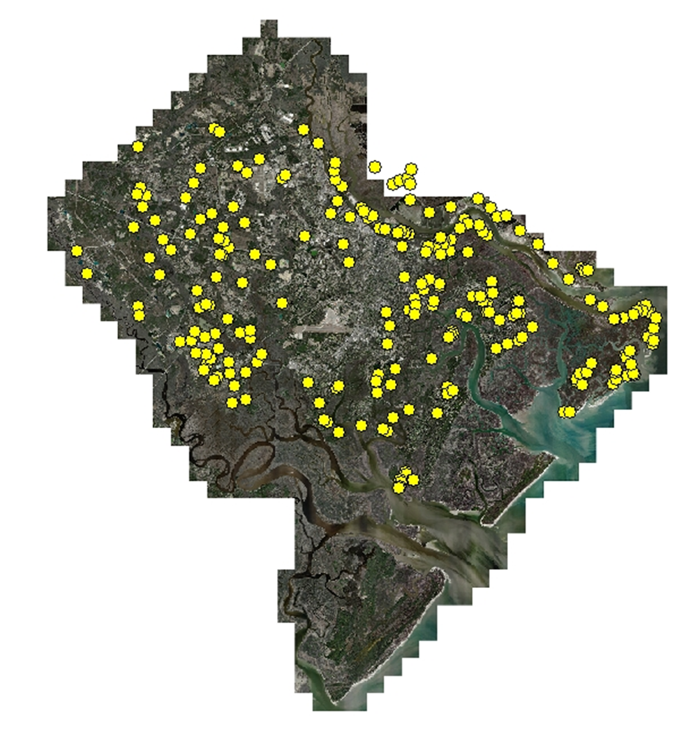
Figure A - Inspection sites treated by aircraft

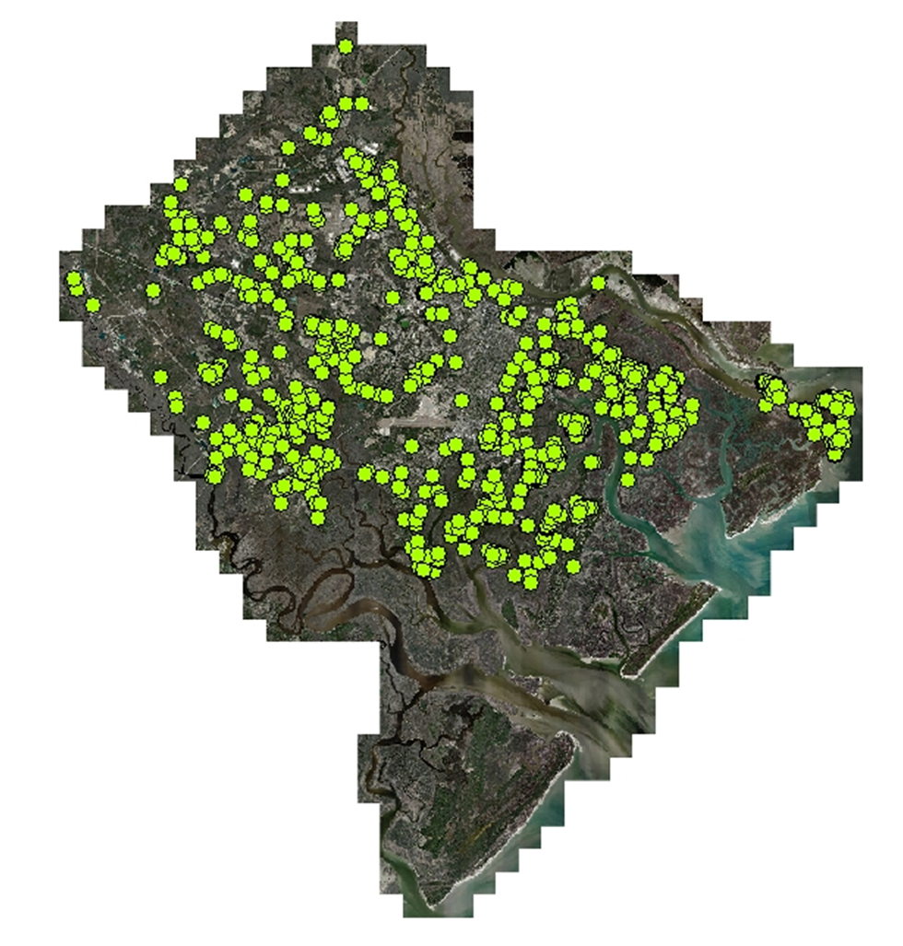
Figure B - Inspection sites treated by hand

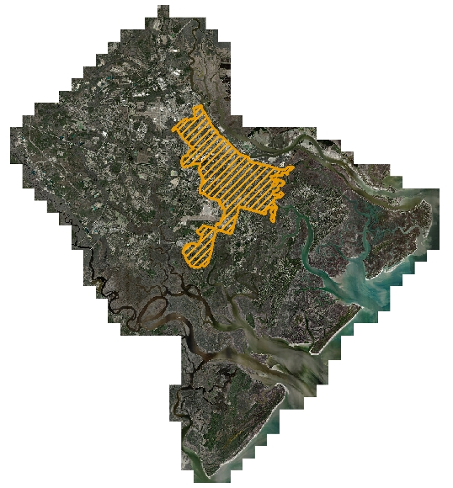
Figure C - Region of county where storm drains/catch basins are treated

  - Water Quality Standards - Waterways in Chatham County are not impaired with any pesticides used by Chatham County Mosquito Control.
- Control Measure Description.
  - A description of the control measures to demonstrate how the operators specifically plan to meet the applicable technology-based or water quality-based effluent limitations.
    - No action or at least delayed action may be taken by CCMC at times when a major portion of the county has been inundated with water. When a county wide flooding event takes place it is generally more economical and environmental friendly to allow mosquito larvae to emerge and treat for adults at a later time if necessary. This is because not all larval habitats can be treated in a timely manner to prevent adult emergence, and adult mosquitoes will migrate into our service area from the surrounding regions that have no or reduced mosquito control resources. Conversely, no action may also be taken when sites containing larvae are shallow, and extended weather forecasts indicate dry conditions. Such situations allow larval habitat to dry before mosquitoes can complete their aquatic life stages, and no adults result.
    - Prevention; mechanical/physical methods; and cultural methods are by definition very similar in nature and share many characteristics. These methods can be as basic as simply emptying water from containers or as complex as repairing broken water lines which often require the involvement of other county departments, such as Public Works. Educational programming at local schools and area events allow CCMC staff the opportunity to suggest ways that residents can assist in the prevention of mosquito problems by removing containers and articles from their yards that provide larval habitat, and to be mindful that birdbaths and pet water bowls could serve as mosquito sanctuaries when not properly maintained.
    - Mechanical/physical methods, in which the habitat is physically altered to remove or reduce the amount of available larval habitat, is not a method of control CCMC commonly incorporates outside the Savannah River Basin area of our service area. In this region, the Core of Engineers manages an extensive river maintenance program for the ship traffic associated with Savannah’s robust port industry. Ditching projects along the Georgia side of the channel conducted by CCMC take place primarily on Hutchison Island under a predetermined time table at the discretion of the Army Core of Engineers. These projects are designed to reduce available larval habitat by accelerating the draining process through the creation of large ditches. Ditch systems are currently configured with a centralized reservoir stocked with Gambusia fish to provide a means of Biological control should any future river dredging/pumping or heavy rains stimulate a mosquito hatch off (also see above).
    - Cultural methods, like the previous two methods, manipulate larval habitat to prevent favorable conditions for mosquitoes to complete their aquatic development. Physical manipulation of environments such as removing blockages in ditches that serve as barriers to natural predators of mosquitoes are sometimes quick and effective means for our Entomology Technicians to resolve problems on a localized level (also see above).
    - Biological control agents: CCMC uses various biological control agents for the control of larval stages of mosquitoes. Formulations containing Bacillus sphaericus and/or Bacillus thuringiensis israelensis are used to treat flood water and salt-marsh mosquito larval sites with our helicopter. These products are also used in alternating years to treat catch basin/storm drains, as a precaution against resistance in our primary WNV vector species.
    - Pesticides often are any abatement agency’s last choice of control measures. These products are applied as directed by their respective label, and all equipment used in this process is closely monitored and calibrated by staff.

Operators must consider impact to non-target organisms, impact to water quality, pest resistance, feasibility, and cost effectiveness when evaluating and selecting the most efficient and effective means of pest management to minimize pesticide discharge to waters of the U.S.
  - A brief explanation of the control measures used at the site to reduce pesticide discharge, including evaluation and implementation of the six pest management tools:
    - No action or at least delayed action may be taken by CCMC at times when a major portion of the county has been inundated with water. When a county wide flooding event takes place it is generally more economical and environmental friendly to allow mosquito larvae to emerge and treat for adults at a later time if necessary. This is because not all larval habitats can be treated in a timely manner to prevent adult emergence, and adult mosquitoes will migrate into our service area from the surrounding regions that have no or reduced mosquito control resources. Conversely, no action may also be taken when sites containing larvae are shallow, and extended weather forecasts indicate dry conditions. Such situations allow larval habitat to dry before mosquitoes can complete their aquatic life stages, and no adults result.
    - Prevention, mechanical/physical methods and cultural methods are by definition very similar in nature and share many characteristics. These methods can be as basic as simply emptying water from containers or as complex as repairing broken water lines which often require the involvement of other county departments, such as Public Works. Educational programming at local schools and area events allow CCMC staff the opportunity to suggest ways that residents can assist in the prevention of mosquito problems by removing containers and articles from their yards that provide larval habitat, and to be mindful that birdbaths and pet water bowls could serve as mosquito sanctuaries when not properly maintained.
    - Mechanical/physical methods in which the habitat is physically altered to remove or reduce the amount of available larval habitat is not a method of control CCMC commonly incorporates outside the Savannah River Basin area of our service area. In this region, the Core of Engineers manages an extensive river maintenance program for the ship traffic associated with Savannah’s robust port industry. Ditching projects along the Georgia side of the channel conducted by CCMC take place primarily on Hutchison Island under a predetermined time table at the discretion of the Army Core of Engineers. These projects are designed to reduce available larval habitat by accelerating the draining process through the creation of large ditches. Ditch systems are currently configured with a centralized reservoir stocked with Gambusia fish to provide a means of Biological control should any future river dredging/pumping or heavy rains stimulate a mosquito hatch off (also see above).
    - Cultural methods like the previous two methods manipulate larval habitat to prevent favorable conditions for mosquitoes to complete their aquatic development. Physical manipulation of environments such as removing blockages in ditches that serve as barriers to natural predators of mosquitoes are sometimes quick and effective means for our Entomology Technicians to resolve problems on a localized level (also see above).
    - Biological control agents: CCMC uses various biological control agents for the control of larval stages of mosquitoes. Formulations containing Bacillus sphaericus and/or Bacillus thuringiensis israelensis are used to treat flood water and salt-marsh mosquito larval sites with our helicopter. These products are also used in alternating years to treat catch basin/storm drains, as a precaution against resistance in our primary WNV vector species.
    - Pesticides often are any abatement agency’s last choice of control measures. These products are applied as directed by their respective label, and all equipment used in this process is closely monitored and calibrated by staff.

Operators must consider impact to non-target organisms, impact to water quality, pest resistance, feasibility, and cost effectiveness when evaluating and selecting the most efficient and effective means of pest management to minimize pesticide discharge to waters of the U.S.
  - Control measures are evaluated separately on the basis of mosquito life stage as follows:
    - Adult control efficacy is determined from pre and post treatment trap counts when a trap site is located within the spray block. In addition, landing rates taken by staff are used to supplement this data when trap sites are not located near a treatment area.
    - Larval control efficacy is more difficult to access, as our primary larvicide product is a growth hormone that does not cause mortality until the later stages of the larvae’s development. Often, in this case, a failure is not realized until “healthy” adults are found emerging after their pupal stage. However, post-treatment surveys do verify successful treatments when using larvicide oils and films, or biological control measures, such as Gambusia or Bti products.
- Schedules and Procedures
  - Pertaining to Control Measures Used to Comply with the Effluent Limitations in Part 2.
    - Application Rate and Frequency Procedures.
      - Application Rate Determination
        - Determine species and age of target mosquito(es).
        - Evaluate environmental conditions.
        - Consider target area flora and fauna.
        - Determine appropriate application rate based on product label recommendations, previous experience and efficacy tests.
      - Frequency Determination
        - Determine target site treatment history with selected pesticide.
        - Consider pesticide label limitations regarding application frequency and quantity.
        - Consider alternate treatment options.
      - Resistance Considerations
        - Consider resistance of target species to selected pesticide and/or any other compounds that are in the same class or exhibit similar modes of action. Also consider the possibility of cross resistance.
        - Consider the use of alternate control options.
    - Spill Prevention Procedures
      - Perform daily and weekly inspections of chemical storage buildings, pumping systems and hazardous waste storage areas. Maintain buildings and pumping system to full function ability.
      - Refer to CCMC Hazardous Waste Inspection Log and Refer to CCMC Emergency Action Plans:

Section 2: Chemical Spill Response Plan, Spill Response Supplies and PPE Locations, CCMC Chemical List and PPE Requirements.
    - Pesticide Application Equipment Procedures
      - Ground Adulticiding
        - Operations:
          - Application equipment must be calibrated annually to confirm the Volume Median Diameter is according to the label of the pesticide being used.
          - A visual inspection of spray equipment for leaks or wear in the lines and tanks is done prior to the start up of spray equipment.
          - Routine cleaning and maintenance of the spray system must be performed to ensure system is operating properly.
        - Maintenance:
          - Visually check the fog generator before and after each use and make any necessary adjustments and /or repairs.
          - Follow equipment manufacturer’s recommended maintenance schedule.
          - Set appropriate flow rate and determine droplet size spectrum per pesticide label. This is to be conducted annually and after completing major repairs or modifications.
          - Repairs and services on ULV equipment will be performed by an assigned mechanic only.
      - Aerial Adulticiding. Rotary aircraft used for applications of liquid products to control adult mosquitoes. Application equipment is calibrated to manufacturer’s specification listed on the label of each pesticide used by our organization. Equipment is calibrated prior to each season, and also whenever such equipment is modified or replaced. All aerial equipment is inspected by flight crews before each mission for external damage or leaks.
      - Ground larviciding is conducted by CCMC staff in a number of situations using various products throughout the season.
        - Hand treatments are conducted within Chatham County by licensed personnel using their best professional judgment. These treatments generally take place after rain or extreme tidal events, although some sites are pretreated where historic data justifies such actions. Equipment used during hand treatment work include small 1 gallon or 1 quart sized hand sprayers, and pressurized 15 gallon truck-mounted sprayers. Truck-mounted sprayers are calibrated prior to each season.
        - Catch basins within an area of the county historically known to harbor West Nile virus are treated on a schedule to prevent human illness. Basins are treated with approved larvicides.
      - Aerial larviciding treatments are based on field surveillance and best professional judgment, and are conducted as necessary throughout the mosquito season.
- Fixed wing larvicide treatments are applied with a single engine 1994 Air Tractor 402A over large sites (generally over 60 acres in size). Such applications are made with an approved larvicide.

- Rotary wing treatments are also conducted using an approved larvicide. As with the fixed wing, calibration of larviciding equipment is carried out prior to the season, and again after any in-season modifications to the system for EACH product used.

    - Pest Surveillance Procedures
      - Adult Surveillance
        - Service request inspections are taken during normal working hours and from telephone messages or emails outside of the normal work day. Many of these are simple requests for treatments, although occasionally such calls lead to finding problems needing attention. Technicians generally will check for mosquito larvae and determine if adult populations warrant treatment during these inspections from observed densities.
        - Gravid trap collections are paramount to our WNV surveillance. This trap type is particularly effective in catching gravid Culex quinquefasciatus, which is our primary WNV vector. Gravid traps are deployed throughout the county each week during the mosquito season.
        - CDC light trap collections are used for both nuisance mosquito census and EEE surveillance on a weekly basis.
      - Larval Surveillance
        - Service request inspections preformed by our Entomology Technicians will check for mosquito larvae and determine if adult populations warrant treatment during these inspections from observed densities. Generally, these requests for service stem from localized, container-breeding species of mosquitoes that are easily remedied by simply dumping water from articles such as buckets, birdbaths, tarps, and other items that are holding water. Occasionally, service requests investigations uncover larger scale problems, like blocked drainage systems, leaking septic tanks, broken water lines, etc. that may require further action by either the land owner or other county departments to correct.
        - Breeding site inspections are conducted by our Entomology Technicians following flooding events caused by rains, spring tides, or high river stages. Large areas that may require aerial treatments are inspected before the smaller, hand-treated sites. Larval surveillance entails locating the larval source (if not already known), sampling for larvae and estimating larval density, determining larval developmental stage(s), and collecting larvae for identification purposes. Other factors considered during larval inspections include the water depth at the specific location, current extended forecast, water temperature, and if any natural predators (like Gambusia) are present.
      - Disease Surveillance
        - Sentinel chicken flock are used in our more rural regions of the county primarily for EEE surveillance. Currently, six fixed locations are rigged with a chicken hanger system that allows us to elevate caged chickens into the lower tree canopy. Individual chickens are left over night, and returned to Mosquito Control the next morning. Following a two week incubation period, blood samples from individual birds are tested for both EEE and WNV.
        - Mosquito pool analysis is a most useful indicator of the presence of WNV (and occasionally EEE) in our service area. Up to 25 adult Culex or Culiseta melanura mosquitoes are grouped to form a single sample for WNV or EEE virus analysis, respectively.
        - Dead bird lab work during our early history with WNV played a role in the initial detection of areas of high concern. However, this aspect of viral detection has been diluted over the years as we have become more familiar with the ecology of this virus and our local bird populations. More recent work conducted throughout the US has established that three groups of birds (crows, blue jays, and raptors) are more susceptible to WNV than others. Currently, we record all dead birds reported to us, but seldom submit dead birds for viral analysis.
    - Assessing Environmental Conditions Procedures.
      - General Considerations. Climatic conditions are always checked prior to any aerial or ground applications. Wind speed, wind direction, air temperature, and the possibility of impending rain must be taken into consideration whether applying liquid or solid products because of drift, dilution, or chemical breakdown depending on the product being used. No applications are made when temperatures fall below 50°F.
      - Adult mosquito treatments. Treatments for adult mosquitoes occur in both urban and rural areas of the county. Applicators are always aware of nearby salt-marsh areas, and turn spray equipment off when necessary to avoid drift into such areas.
        - Aerial Adulticiding Procedures.
          - Follow label instructions. Spray during periods when ground level wind speed is equal to or greater than 1 mph. Apply when thermal activity is low. Do not apply when ambient temperature is less than 50ºF. Do not apply when it is raining in the treatment area.
          - Bee keepers requesting notification are contacted prior to spraying their area to help protect their colonies.
          - Other individuals requesting notification are contacted prior to spraying their area.
        - Ground Adulticiding Procedures.
          - Follow label instructions. Apply when insects are most active and meteorological conditions are conducive to keeping the spray cloud in the air column close to the ground. Do not apply when air temperature is less than 50 F.
          - Bee keepers requesting notification are contacted prior to spraying their area to help protect their colonies.
          - Other individuals requesting notification are contacted prior to spraying their area.
      - Larval mosquito treatments. Two major environmental considerations are tree canopy and the amount of aquatic vegetation present within the treatment site. Tree canopy may deflect or otherwise prevent the penetration of pesticide from reaching the target area. Heavy vegetation within a wetland can interfere with the migration of the larviciding agent through the water column.
  - Pertaining to Other Actions Necessary to Minimize Discharges
    - Spill Response Procedures
      - Chemical Spill Response OSHA Level II training is required for staff handling, loading or applying pesticides.
      - Refer to CCMC Emergency Action Plans:

Section 2: Chemical Spill Response Plan, Spill Response Supplies and PPE Locations, CCMC Chemical List and PPE Requirements.

Section 3: Points of Contact

Section 6: Medical Facilities
    - Adverse Incident Response Procedures.
      - Procedures for responding to any incident resulting from pesticide applications. Complete Adverse Incident Report form.
      - Procedures for notification of an incident:
        - Refer to CCMC Emergency Action Plans:

Section 2: Chemical Response Plan, CCMC Chemical List

Section 6: Emergency Medical Facilities
      - To help avoid or at least minimize adverse incidents, CCMC applicators turn off spray equipment when approaching areas with high human activity, such as outdoor sport practices, games, or other events. We also maintain a proactive courtesy call list for individuals that have informed us of any sensitivity to the products we use, enabling these individuals to avoid contact from these products all together. In addition, our courtesy call list extends to backyard organic gardeners and beekeepers to insure the integrity of their crop and the safety of their apiary, respectively. Prior to aerial spraying faxes are sent to all local police precincts and participating county municipalities that define treatment areas and aid in informing the public.

