The City Of Hinesville Mosquito Control Pesticide Discharge Management Plan

The City of Hinesville Ga. Mosquito Control
613 E.G. Miles Pkwy
Hinesville, Ga. 31313
Office: 912-876-8216

- Pesticide Discharge Management Team. All persons may be contacted at:

CH2MHILL-OMI, 613 E.G. Miles Pkwy. Hinesville Ga. 31313 (912) 876-8216.

  - Person(s) responsible for managing pests in relation to the pest management area.

  - Person(s) responsible for developing and revising the PDMP.

  - Person(s) responsible for developing, revising, and implementing corrective actions and other effluent limitation requirements.

  - Person(s) responsible for pesticide applications (mix, load, apply).

- Pest Management Area Description :
- Pest Problem Area Description: Cities of Hinesville and Flemington, Georgia are located in Liberty County, which is in the Lower Coastal Plain Physiological Region of the state. The total square miles for Hinesville GA are 21.18. The total square miles for Flemington GA are 4.7. The area is bordered by Fort Stewart Army Installation to the North, Long County to the West, the cities of Allenhurst and Walthourville to the South, and Liberty County to the East. Hinesville has Terrell’s Millpond within its city limits and Davis Swamp outside its city limits to the east. The area has Horse, Mill and Peacock Creeks draining through.

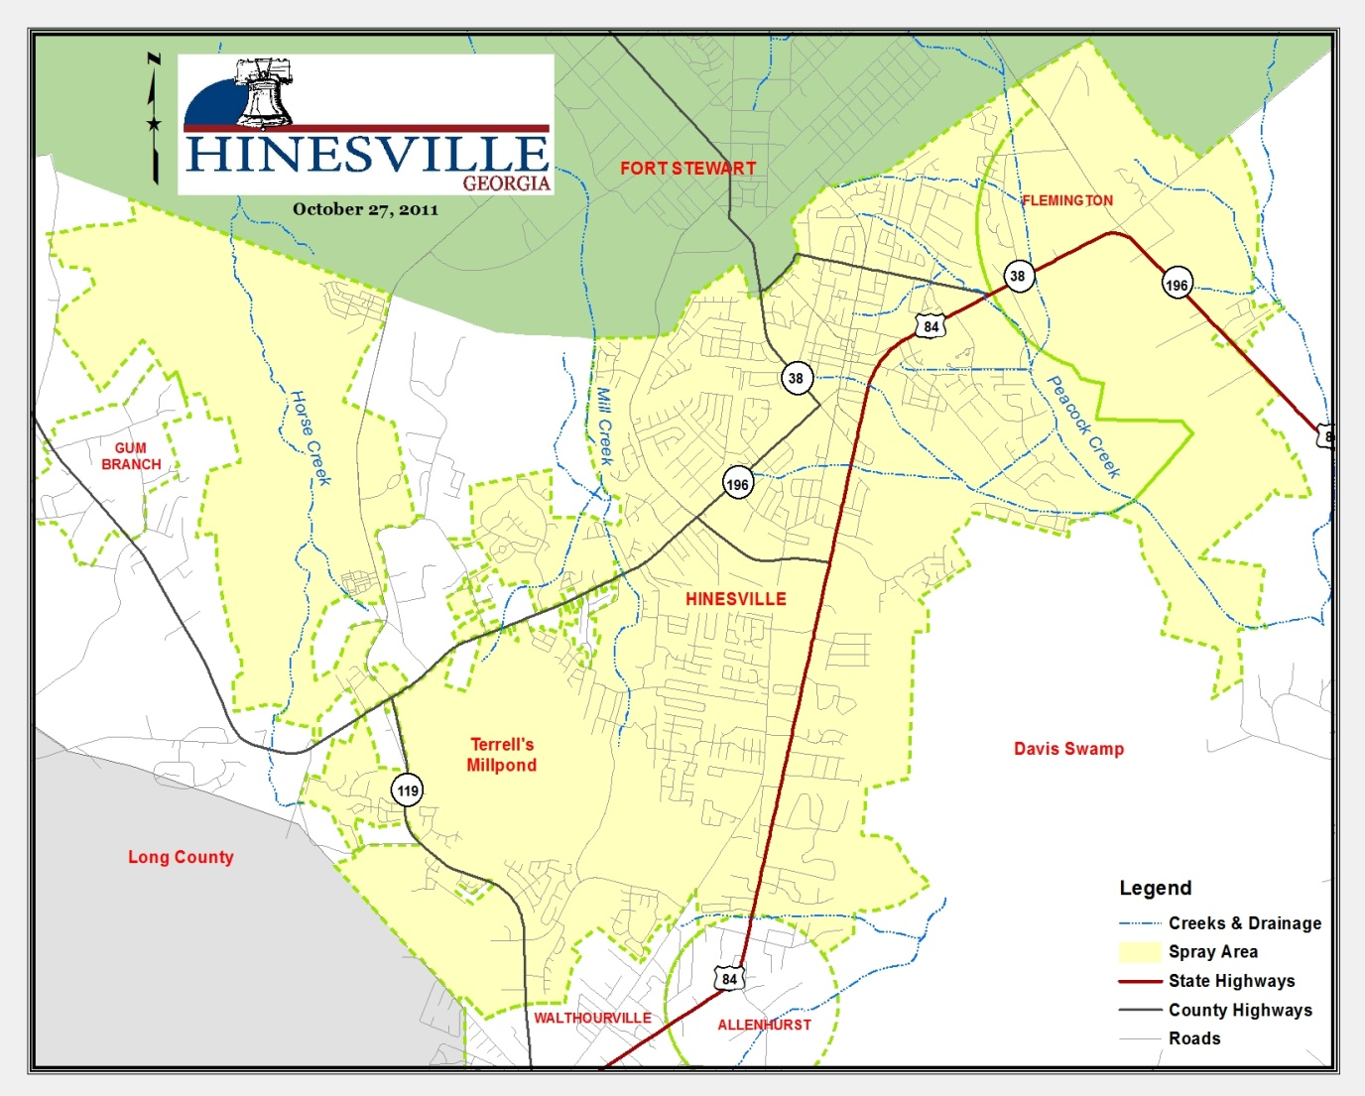
      - Natural Environments
1. Mill and Peacock Creeks serves as floodplains draining through Hinesville GA. These flood plains can serve as habitats for Culiseta melanura, Psorophora ferox, and a number of floodwater Ochlerotatus species.

1. Isolated wetlands such as sloughs and depressions caused by uprooted trees occur throughout Hinesville GA. Many of these sites only contain water during the wet seasons of the year, and serve as excellent nurseries for many species of mosquitoes found in our region.

2. Other natural environments include tree holes, tree cavities, burrows made by various species of wildlife. These as a whole are generally not a pressing concern to our mosquito control program, although tree holes play a major role in the biology of Ochlerotatus triseriatus, which is the primary vector of LaCrosse Encephalitis virus in the United States.
      - Man-made Environments
        - Ditches and canals are frequently suggested as sources of mosquito problems by the general public. However, these structures usually contain fish, and are seldom the primary source of a mosquito infestation, especially if these systems tend to hold water on a permanent basis. On the other hand, shallow roadside ditches do contribute to mosquito populations at times. Such sites often remain dry throughout much of the year or because of temperature, oxygen content, or other factors do not support fish life. Mosquito species encountered in such sites include Culex salinarius, Cx. restuans, and many Ochlerotatus species.
        - Clear-cuts are often the result of future residential subdivisions. Such work tends to scar the land with trenches and ruts from the heavy equipment used in the process. These newly established “lows” can hold water for prolonged periods of time, especially without the aid of water translocation previously carried out by the now absent forest. Such areas can be productive as larval mosquito sites until they are developed or regenerate. Initially, such sites may harbor Culex mosquitoes, including Cx. quinquefasciatus, because of the excess of rotting plant material left after clear-cutting work.
        - Storm drains and catch basins are found throughout the city and provide a suitable environment for Culex quinquefasciatus, which is Georgia’s primary WNV vector.
        - Containers come in all sorts of shapes and sizes. These may be represented by something as small as a bottle top to something as large as a discarded or unkempt boat. Containers serve as the primary larval site for Aedes albopictus.
        - Other man-made sites include borrow pits, and retention and detention ponds. These areas generally do not cause problems except during drought conditions, as many will contain fish.

  - Pest Problem Description
    - The Cities of Hinesville and Flemington, Georgia are located in Liberty County, which is in the Lower Coastal Plain Physiological Region of the state. The area is bordered by Fort Stewart Army Installation to the North, Long County to the West, the cities of Allenhurst and Walthourville to the South;, and Liberty County to the East. Hinesville has Terrell’s Millpond within its city limits and Davis Swamp outside its city limits to the east. The area has Horse, Mill and Peacock Creeks draining through.

      - Aedes albopictus, the Asian tiger mosquito, is one of the primary nuisance species in Hinesville GA. This species is a container breeding mosquito, and is commonly associated with the more urbanized areas in the county. However, it can also be an abundant species in the more rural regions of the county, especially in the vicinity of trash piles or tire dumps. It is a fierce daytime biter and can potentially be a vector for WNV and other arboviral diseases.
      - Aedes vexans is a common woodland mosquito that has the potential to fly up to 5 miles. It is generally encountered in the spring, but can be found at other times of the year as well. This species has been implicated as a vector of eastern equine encephalitis (EEE), West Nile virus (WNV), and dog heartworm.
      - Coquillettidia perturbans, is a fairly large mosquito that is often associated with aquatic habitats containing cattails, Typha spp. It is generally considered a bridge vector of EEE to mammals, but has also tested positive for WNV in the United States. It commonly takes blood meals from both bird and mammal species (including humans) and will fly up to 10 miles for a blood meal.
      - Culex quinquefasciatus, the southern house mosquito, is our region’s primary WNV vector. It prefers somewhat stagnant or polluted water conditions as larval habitat, and can be a common species in storm drain systems, especially in drainage lines equipped with sumps in the catch basins that tend to hold water on a permanent basis.
      - Culex restuans, is an early season mosquito that precedes Culex quinquefasciatus in our area. Larval habitats for this species typically include a variety of semi-permanent waterways, including roadside ditches and woodland pools. It has been reported to carry both EEE and WNV outside of Georgia, and may be an important vector in the initial amplification of these viruses in bird populations, as birds appear to be its primary blood hosts.
      - Culex salinarius is a common mosquito throughout much of the year in our region. Adults are readily attracted to light traps and larvae are found in both freshwater and somewhat saline environments. This species has been recorded to carry dog heartworm, EEE, SLE, and WNV. It appears to be an opportunistic feeder of birds, mammals, and even reptiles, and may serve as an important bridge vector in the transmission of arbovirus in the southeastern United States.
      - Culiseta melanura is a swamp mosquito that occurs in cypress – hardwood floodplains and other aquatic habitats characterized by low pH. The larvae often are found within subterranean pockets that are difficult to treat with conventional larvacides agents. This species almost exclusively obtains its blood meals from birds, and therefore is the primary vector in the amplification of EEE in our area. It has also been found to carry western equine encephalitis (WEE) and WNV elsewhere in the United States.
      - Ochlerotatus taeniorhynchus, the black salt-marsh mosquito, is a serious nuisance mosquito species that is capable of producing tremendous numbers of adults after coastal flooding events caused by rains or extreme high tides. Such emergences may curtail outdoor activity of residents, and can wreck havoc on the local economy, especially during outdoor events, or for businesses located in or near our coastal region. This species has been found to carry Saint Louis Encephalitis (SLE) and WNV in Florida and EEE in South Carolina.
      - Psorophora columbiae, the rice field mosquito, is often associated with flooded open grassy areas in our area. It is a strong flyer that prefers feeding on mammals, and can be a serious nuisance mosquito during the summer and fall.
      - Psorophora ferox is a flood-water mosquito species common in many of our hardwood/cypress areas and other freshwater habitats. It can be a serious pest in many subdivisions that border these areas. It has also been reported to carry EEE and WNV in Mississippi and New York, respectively.
  - Action Threshold
    - To better guide Hinesville GA treatments for adult mosquitoes, thresholds were re-established during the 2011 season because of the growing concern over West Nile virus (WNV). Prior to 2011, existing thresholds were primarily directed for the control of nuisance mosquitoes. However, in 2001 there was a re-emergence of the WNV in the surrounding counties, increasing the probability of WNV transmission to citizens or guests within the city limits of Hinesville GA. It became apparent that we needed to establish a program that will better protect and serve the citizens and guest of Hinesville GA, so the threshold levels below were established at what we conceived to be levels that would reduce both nuisance and vector mosquito species based on mosquito surveillance data collected in 2011. The following thresholds will be subject to change as we fine tune our program based on changes to mosquito surveillance techniques.
      - ≥ 15 Culex quinquefasciatus from any trap site prior to detection of WNV in the City.
      - ≥ 5 Culex quinquefasciatus from any trap site after detection of WNV in the city.
      - ≥ 10 Culex quinquefasciatus from any trap site where WNV has been detected previously.
      - ≥ 3 complaint calls from a single ULV spray zone during a 1 week period.
      - ≥ 15 complaint calls across the entire city during a 1 week period.
      - Reports from staff of landing rates ≥ 5 mosquitoes at any inspection site.
      - ≥ 10 nuisance mosquitoes in a CDC trap.
      - Technicians reporting a larviciding failure at any breeding site located near populated areas.
      - ≥ 5 Culiseta melanura collected from a CDC trap.
      - Based on a service request, limited area treatments may be conducted prior to special events or community functions.
    - As of January 1, 2012 the following thresholds will be established to trigger larviciding missions within our service area:
      - Treatments of larval mosquito habitat may be conducted in areas that are found to contain an average of at least 1 larva per dip (using a standard 12 oz. dipper). Actual treatments will be based on local demographics, mosquito species present, and other historic and current conditions.
      - The storm water system will be treated in selected areas of the city where we find that the structures hold water longer than 4 days or for periods of time that will support the growth, or serve as a habitat, for vector species to breed.
      - After an ongoing monitoring plan reveals that certain storm structures (catch basins) reveal a pattern of support for the breeding of vector species, whenever possible, after a major rain those storm drains will be inspected and treated accordingly.

  - General Location - After January 1, 2012 The City of Hinesville GA will treat storm drains and catch basin on a monthly basis during the mosquito season. This will be the first time that the City of Hinesville will treat catch basins, so at this time, the number of catch basins to be treated monthly is unknown. We have included maps of the areas that may be potentially treated and areas that will be treated. Figure (A) includes storm drains that may potentially be treated by larvacides. Figure (B) includes areas that will be treated by adulticide during the season.

Figure A – STORM DRAINS
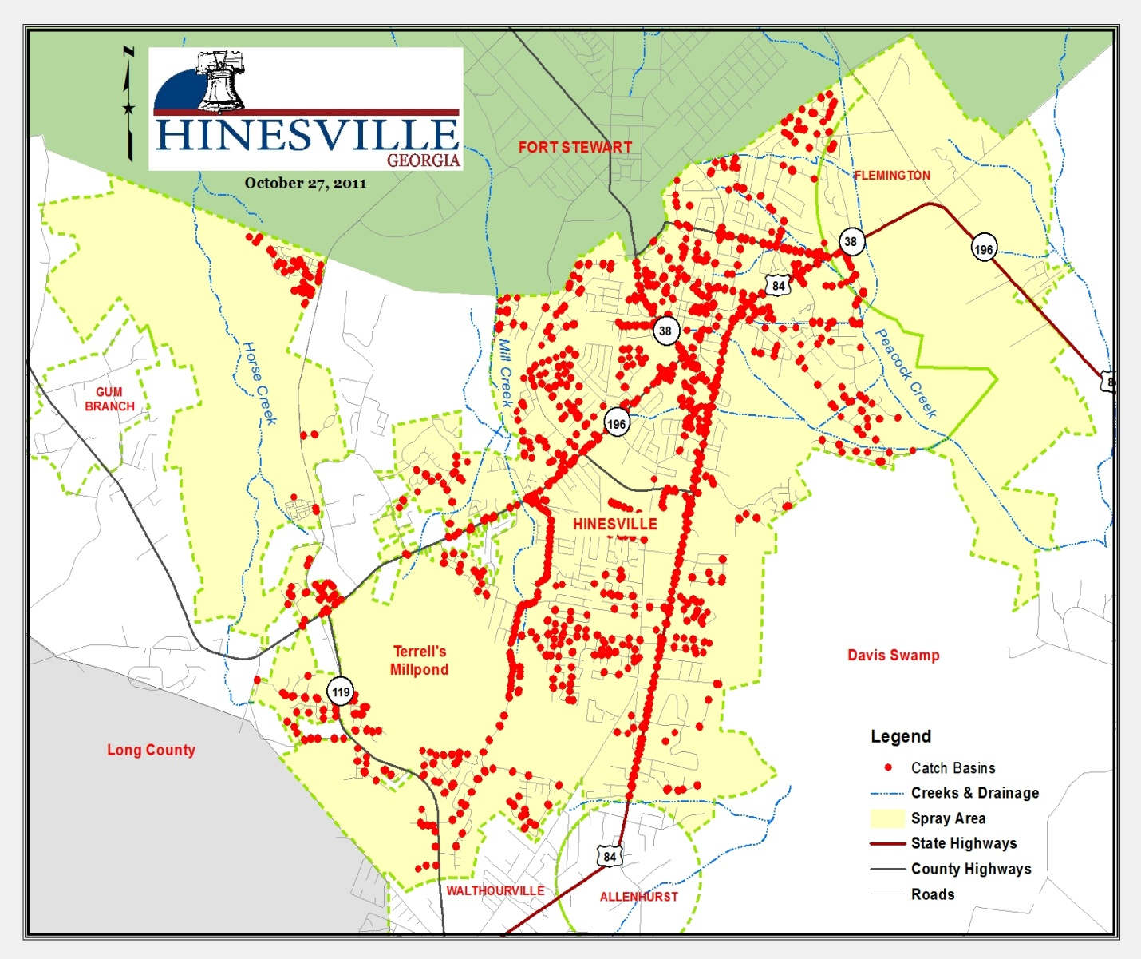
FIGURE B -Areas that will be treated by adulticide.

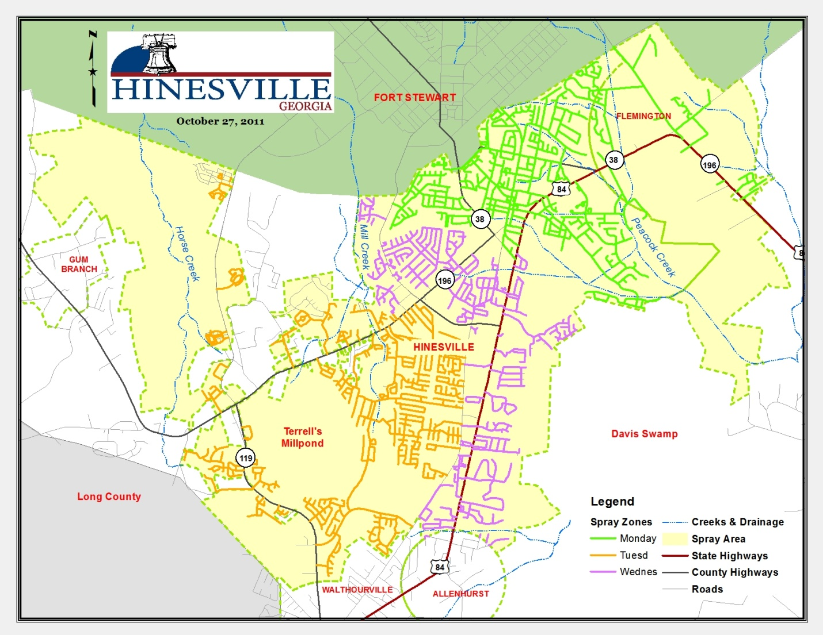

  - Water Quality Standards - Waterways in Hinesville Georgia are not impaired with any pesticides used by Hinesville Georgia Mosquito Control.
- Control Measure Description.
  - A description of the control measures to demonstrate how the operators specifically plan to meet the applicable technology-based or water quality-based effluent limitations.
    - No action or at least delayed action may be taken by Hinesville Georgia at times when a major portion of the county has been inundated with water. When a county or city wide flooding event takes place it is generally more economical and environmental friendly to allow mosquito larvae to emerge and treat for adults at a later time if necessary. This is because not all larval habitats can be treated in a timely manner to prevent adult emergence, and adult mosquitoes will migrate into our service area from the surrounding regions that have no or reduced mosquito control resources. Conversely, no action may also be taken when sites containing larvae are shallow, and extended weather forecasts indicate dry conditions. Such situations allow larval habitat to dry before mosquitoes can complete their aquatic life stages, and no adults result.
    - Prevention, mechanical/physical methods and cultural methods are by definition very similar in nature and share many characteristics. These methods can be as basic as simply emptying water from containers or as complex as repairing broken water lines, which often requires the involvement of other city departments, such as Public Works. Educational programs at local schools, the city’s website and area events allow Hinesville GA staff the opportunity to suggest ways that residents can assist in the prevention of mosquito problems by removing containers from their yards that provide larval habitat, and to be mindful that birdbaths and pet water bowls that could serve as mosquito larval sites when not properly maintained.
    - Whenever site inspection performed by a technician reveals that mechanical/physical methods (in which the habitat is physically altered to remove or reduce the amount of available larval habitat) is the best practice for the specific situation, the technician or the corresponding department will, and while under the supervision of a technician, will implement the prescribed methods.
    - Cultural methods are also methods used to manipulate larval habitat to prevent favorable conditions for mosquitoes to complete their aquatic development. These methods includes but are not limited to proper mowing and trimming techniques that reduce the resource areas required by mosquitoes for resting sites. Physical manipulation of environments such as removing blockages in ditches that serve as barriers to natural predators of mosquitoes along with cultural practices are methods that the City of Hinesville have been performing and will continue to perform on a schedule basis or as the need arrives.

    - Pesticides often are any abatement agency’s last choice of control measures. These products are applied as directed by their respective label, and all equipment used in this process is closely monitored and calibrated by staff.

Operators must consider impact to non-target organisms, impact to water quality, pest resistance, feasibility, and cost effectiveness when evaluating and selecting the most efficient and effective means of pest management to minimize pesticide discharge to waters of the U.S.

A brief explanation of the control measures used at the site to reduce pesticide discharge, including evaluation and implementation of the six pest management tools:
    - no action
    - prevention
    - mechanical/physical methods
    - cultural methods
    - biological control agents
    - pesticides

Operators must consider impact to non-target organisms, impact to water quality, pest resistance, feasibility, and cost effectiveness when evaluating and selecting the most efficient and effective means of pest management to minimize pesticide discharge to waters of the U.S.
  - Control measures are evaluated separately on the basis of mosquito life stage as follows:
    - Adult Control efficacy is determined from pre and post treatment trap counts when a trap site is located within the spray block. In addition, landing rates taken by staff are used to supplement these data when trap sites are not located near a treatment area.
    - Larval control efficacy is more difficult to access, as our primary larvicide product is an insect growth regulator that does not cause mortality until the later stages of the larva’s development. Often, in this case, a failure is not realized until “healthy” adults are found emerging after their pupal stage. However, post-treatment surveys do verify successful treatments when using larvicide oils and films, or biological control measures, such as Gambusia or BTI products.
- Schedules and Procedures.
  - Pertaining to Control Measures Used to Comply with the Effluent Limitations in Part 2.
    - Application Rate and Frequency Procedures.
      - Application Rate Determination
        - Determine species and age of target mosquito(es)
        - Evaluate environmental conditions
        - Consider target area flora and fauna
        - Determine appropriate application rate based on product label recommendations, previous experience and efficacy tests.
      - Frequency Determination
        - Determine target site treatment history with selected pesticide
        - Evaluate effect of selected pesticide use on frequency and quantity thresholds for active ingredient.
        - Consider alternate treatment options
      - Resistance Considerations
        - Consider documented resistance of target species to selected pesticide and/or any other compounds that are in the same class or exhibit similar modes of action. Also consider the possibility of cross resistance.
        - Consider the use of alternate control options.
    - Spill Prevention Procedures.
      - Perform daily and weekly inspections of chemical storage buildings, pumping systems and hazardous waste storage areas. Maintain buildings and pumping system to full function ability.
      - Refer to CH2MHILL-OMI Emergency Action Plans:

Section 2: Chemical Spill Response Plan, Spill Response Supplies and PPE Locations, CH2MHILL-OMI Chemical List and PPE Requirements.
    - Pesticide Application Equipment Procedures.
      - Ground Adulticiding
        - Operations:
          - Application equipment must be calibrated annually to confirm the Volume Median Diameter is according to the label of the pesticide being used.
          - A visual inspection of spray equipment for leaks or wear in the lines, tanks and nozzle is done prior to the start up of spray equipment.
          - Routine cleaning and maintenance of the spray system must be performed to ensure system is operating properly.
        - Maintenance:
          - Daily Checks - Visually check the fog generator each day before use and make any necessary adjustments and /or repairs. Before making any repairs ensure that required PPE is worn.
            - Check all gasoline hoses, insecticide lines and fittings for cracks, leaks or wear. Replace if needed.
            - Check all bolts and fasteners and tighten as necessary.
            - Ensure that pesticide tanks have sufficient chemicals for assigned spray mission.
            - Check all nozzle parts for wear or physical damage. Replace damaged parts.
            - Inspect blower air filter for cleanliness and serviceability.
            - Check engine oil. Add oil as needed.
            - Check fuel level.
            - Start engine, listen for any unusual noises and watch for excessive smoke or any engine oil leaks.

          - Every 50 Hours
            - Check the flow rate calibration.
            - Check all gasoline hoses, insecticide lines and fittings for cracks, leaks or wear. Replace if needed.
            - Check all nozzle parts for wear or physical damage. Replace damaged parts as required.
            - Replace blower filter element and wing nut washer.
            - Change blower oil.
            - Grease blower.
            - Change Briggs and Stratton engine oil and filter.
            - Clean insecticide filter.
            - Check the battery for serviceability. Test the battery with a volt-ohmmeter. (Volt reading must be between 11.5 and 12 VDC.)
            - Replace the in-line gasoline filter.
            - Clean blower air vent.
      - Ground Larviciding
    - Pest Surveillance Procedures.
      - Adult Surveillance
        - Service request inspections are taken during normal working hours and from telephone messages or emails outside of the normal work day. Many of these are simple requests for treatments, although occasionally such calls lead to finding problems needing attention. Technicians generally will check for mosquito larvae and determine if adult populations warrant treatment during these inspections from observed densities. In the event that an inspection warrants treatment, the type of adulticide that will be used is MOSQUITOMIST 1.5 ULV. To be sure that the mosquito population don’t develop a resistance, Perm-X UL 4-4 will also be an adulticide that will be employed as part of the City Of Hinesville GA mosquito program.
        - Gravid trap collections will be vital to our WNV surveillance. This trap type is particularly effective in catching gravid Culex quinquefasciatus, which is a primary WNV vector. Two gravid traps will be deployed throughout the city each week during the mosquito season.
        - CDC light trap collections are used for both nuisance mosquito census and EEE surveillance. Four to six CDC light traps will be deployed on a weekly basis.
      - Larval Surveillance
        - Service request inspections preformed by our technicians will check for mosquito larvae and determine if adult populations warrant treatment during these inspections from observed densities. Generally, these requests for service stem from localized, container-breeding species of mosquitoes that are easily remedied by simply dumping water from items such as buckets, birdbaths, tarps, and anything else that is holding water. Occasionally, service requests investigations uncover larger scale problems, like blocked drainage systems, broken water lines, etc. that may require further action by either the land owner, or the city’s departments, i.e. construction maintenance or street department, to correct. If an inspection warrants the use of larvacides, the type of larvacides that will be used will be BTI (Bacillus thuringiensis israelensis) briquets.
        - Breeding site inspections are conducted by our technicians following flooding events caused by rains. Larval surveillance entails locating the larval source (if not already known), sampling for larvae and estimating larval density, determining larval developmental stage(s), and collecting larvae for identification purposes. Other factors considered during larval inspections include the water depth at the specific location, current extended forecast, water temperature, and if any natural predators (like Gambusia) are present.
      - Disease Surveillance
    - Assessing Environmental Conditions Procedures.
      - General Considerations. Climatic conditions are always checked prior to any ground applications. Wind speed, wind direction, and the possibility of impending rain must be taken into consideration whether applying liquid or solid products because of drift, dilution, or chemical breakdown depending on the product being used. Temperature also plays a role in our application methods, especially the timing of application and the choice of products used, as cooler temperatures warrant the use of water-based products while oil-based products are used during warmer temperatures. No applications are made when temperatures fall below 50°F.
      - Adult mosquito treatments. Treatments for adult mosquitoes occur in both urban and rural areas of the city. Equipment is turned off when approaching ponds to avoid any adverse reactions to non-target organisms in these environments.
      - Adult Mosquito samples will be sent to UGA for testing of any viruses.
        - Ground Adulticiding Procedures
          - Apply when insects are most active and meteorological conditions are conducive to keeping the spray cloud in the air column close to the ground.
          - Apply during the cooler hours of the night or early morning when thermal activity is low. Do not apply when ambient temperature is less than 50 F.
          - Apply when ground wind speeds are equal to or greater than 1 mph.
          - Do not apply over bodies of water (lakes, rivers, permanent streams, natural ponds, commercial fish ponds, swamps, marshes or estuaries), except when necessary to target areas where adult mosquitoes are present, and weather conditions will facilitate movement of applied material away from the water in order to minimize incidental deposition into the water body.
          - Pesticide is highly toxic to bees exposed to direct treatment on blooming crops or weeds. Do not apply product or allow drift when bees are actively visiting the treatment area, except when applications are made to prevent or control a threat to public and/or animal health determined by a state, tribal or local health or vector control agency on the basis of documented evidence of disease causing agents in vector mosquitoes, or the occurrence of mosquito-borne disease in animal or human populations, or if specifically approved by the state or tribe during a natural disaster recovery effort.
          - Bee keepers are notified from a call list prior to spraying there area to help in protecting their colonies. A list of bee keepers are kept on record and recorded on the GIS system.
      - Larval mosquito treatments. Two major environmental considerations are tree canopy and the amount of aquatic vegetation present within the treatment site. Heavy vegetation within a wetland can interfere with the migration of the larviciding agent through the water column.
  - Pertaining to Other Actions Necessary to Minimize Discharges.
    - Spill Response Procedures.
      - Chemical Spill Response OSHA Level II training is required for staff handling, loading or applying pesticides.
      - Refer to CH2MHILL-OMI Emergency Action Plans:

Section 2: Chemical Spill Response Plan, Spill Response Supplies and PPE Locations, CH2MHILL-OMI Chemical MSDS and PPE Requirements.

Section 3: Points of Contact

Section 6: Medical Facilities If we don’t have one create one
    - Adverse Incident Response Procedures.
      - Procedures for responding to any incident resulting from pesticide applications
      - Procedures for notification of an incident:
        - Refer to CH2MHILL-OMI Emergency Action Plans:
Section 2: Chemical Response Plan, CH2MHILL-OMI Chemical List
Section 6: Emergency Medical Facilities
      - To help avoid or at least minimize adverse incidents, Hinesville GA applicators turn off spray equipment when approaching areas with high human activity, such as outdoor sport practices, games, or other events. We also maintain a proactive courtesy call list for individuals that have informed us of any sensitivity to the products we use, enabling these individuals to avoid contact from these products all together. In addition, our courtesy call list extends to backyard organic gardeners and beekeepers to insure the integrity of their crop and the safety of their apiary, respectively. All the above information will be kelp on a Geographical Information system for careful monitoring.
    - Pesticide Monitoring Schedules and Procedures.
      - For application by, or under the supervision of, personnel certified/trained in public health pest control or mosquito control. For each application, a record must be kept of:
        - Date, time and areas where application occurred.
        - Type and size of spray nozzle used.
        - Dilution and application rate of pesticide and speed of application vehicle.
        - A description of insecticide delivery system used for the specific application.
        - Climate factors (e.g., ambient temperature, wind speed/direction) as determined using a reliable means.
        - Employees involved in mixing, loading and applying the pesticide.
        - These records must be kept by the responsible public agency or their designee for a minimum of two years using storage methods that will allow the records to be easily retrieved.

