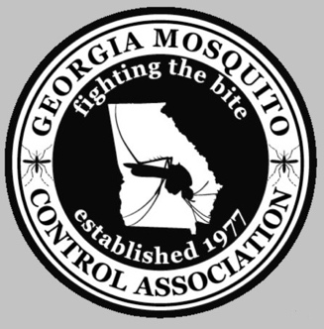
GMCA Membership Only Form

For those of you who would like to be a member but will not be able to attend this year’s meeting! Membership dues are for one year.

Please complete the form and enclose $20.00 per person for Dues Only.

Make check payable to:
Georgia Mosquito Control Association

Date:

Name:

Organization:

Street Address:

City: State: Zip:

Phone: Fax:

Home Address:

Home Phone: Email:

Send this completed form and check to:

GMCA c/o Misty McKanna
1386 Kelly Rd, Statesboro, GA 30461

912-670-1140
Misty.McKanna@dph.ga.gov

